PLANT EXCHANGE
BRING A PLANT OR MAKE DONATION AND TAKE A PLANT
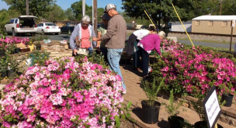
SATURDAY
APRIL 22, 2023
9:00 am — 12:00 pm
Marshville Museum & Cultural Center
201 N. Elm Street
Marshville, NC 28103
Call or Email: 704-624-6214 or mmcc1893@gmail.com
Please Pot and Label Plant Donations! Thank You!

